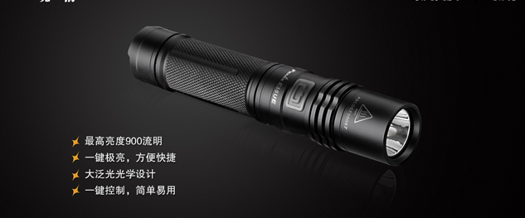
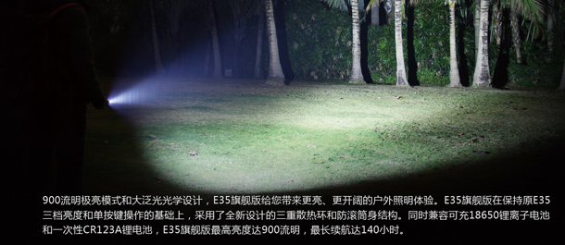
Accessories for LED Flashlight
HS CODE | Product Name | Price | Qty(Pcs) | Amount(US$)
8513901000 | LED flashlight accessories | $15/pcs | 2 | $30
To:
Contact Name :yun seok nam
Address:386 YONGE ST #2201
TORONTO
TORONTO, Ontario, Canada
Zip Code:M5B 0A5
Mobile:6472948929
Tel:647-294-8929
From:
Aliexpress Store: http://www.aliexpress.com/store/1333902
Company: HangZhou WoRong Technology Co. Ltd
Tel: 86-15967129903
Manager: Vincent Chen
Email: master@civillaser.com

For:
Order No 65658530639735 Parcel#4

